‘Generations’ $1200
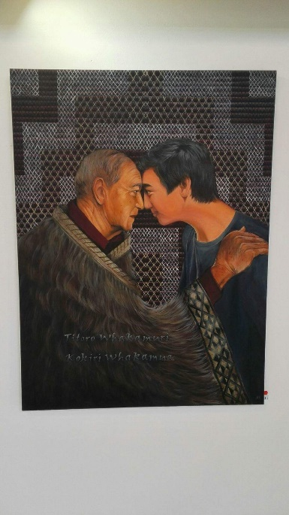
This is about the handing down of wisdom from one generation to the next.
The text is a proverb:
Titoro Whakamuri
Kokiri Whakamua
Look back and reflect, so you can move forward.
During the hongi (pressing of noses) the ha or breath of life is exchanged. The breath of life can also be interpreted as the sharing of both peoples souls.

